Continuous Integration: Concepts, Workflow, and Industry Implementation
1. Introduction to Continuous Integration
Continuous Integration (CI) is a software development practice in which developers frequently integrate their code changes into a shared repository, followed by automated builds and tests. The primary objective of CI is to detect integration issues early, improve software quality, and accelerate the development lifecycle.
Before CI became common, developers worked in isolation for long periods and merged code infrequently. This often resulted in “integration hell”, where conflicts, bugs, and failures were discovered late in the development cycle. CI addresses this problem by enforcing frequent integration, automated verification, and rapid feedback, making it a cornerstone of modern DevOps practices.

2. Core Principles of Continuous Integration
The effectiveness of CI depends on several core principles:
- Frequent Code Commits
Developers commit small changes multiple times a day to a shared version control repository. This reduces merge conflicts and simplifies debugging.
- Single Source Repository
All source code, configuration files, and build scripts are maintained in a centralized repository such as Git.
- Automated Builds
Every commit triggers an automated build process to ensure that the application compiles correctly.
- Automated Testing
Unit tests, integration tests, and regression tests are executed automatically to validate functionality.
- Fast Feedback
Developers are immediately notified if a build or test fails, enabling quick resolution.
- Consistent Build Environment
Builds run in standardized environments to avoid “works on my machine” issues.

3. Difference Between CI, CD, and Continuous Deployment
Although often used interchangeably, CI, Continuous Delivery, and Continuous Deployment represent different stages of automation.
Aspect | Continuous Integration | Continuous Delivery | Continuous Deployment
Purpose | Integrate and test code | Ensure code is deployable | Automatically deploy code
Automation Level | Build + test | Build, test, package | Build, test, deploy
Deployment | Manual | Manual approval | Fully automatic
Example | Jenkins running tests on every commit | Jenkins preparing a release artifact | Code pushed directly to production
Example:
A team using CI ensures that every commit passes automated tests. With Continuous Delivery, the application is always ready for release but deployed manually. In Continuous Deployment, every successful build is automatically released to production without human intervention.

4. Benefits and Challenges of Implementing CI
Benefits
- Early Bug Detection: Errors are identified immediately after code commits.
- Improved Software Quality: Automated testing ensures consistent validation.
- Faster Development Cycles: Reduced rework and quicker releases.
- Enhanced Collaboration: Teams integrate changes frequently and transparently.
- Reduced Integration Risk: Smaller code changes are easier to merge and debug.
Challenges
- Initial Setup Cost: Infrastructure and tooling require upfront investment.
- Maintenance Overhead: CI pipelines and tests must be maintained.
- Flaky Tests: Unstable tests can reduce trust in CI results.
- Learning Curve: Teams need training to adopt CI practices effectively.

5. CI Workflow Components
5.1 Version Control Systems in CI
Version control systems such as Git are the foundation of CI. They manage source code, track changes, and enable collaboration. CI servers continuously monitor repositories and trigger pipelines when new commits are detected.
5.2 Build Automation Tools
Build tools like Maven, Gradle, and Ant automate the compilation and packaging of applications. These tools ensure repeatable builds and eliminate manual errors.
5.3 Automated Testing Frameworks
Automated testing frameworks such as JUnit, TestNG, and Selenium validate application behavior. In CI, tests are executed automatically to detect defects early and ensure stability.
5.4 Artifact Repository Management
Artifact repositories like Nexus and JFrog Artifactory store compiled binaries, libraries, and build outputs. They ensure version control of build artifacts and enable consistent deployments across environments.
5.5 Notification Systems
Notification tools such as email, Slack, and Microsoft Teams alert developers about build statuses. Immediate feedback allows teams to resolve failures quickly and maintain pipeline health.

6.Diagrams
6.1 CI Pipeline
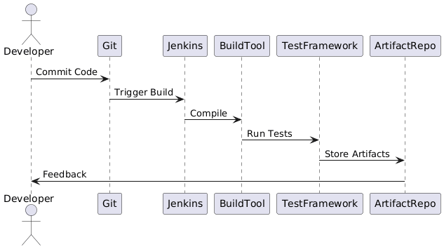

6.1 CI Pipeline

6.2 Jenkins Architecture

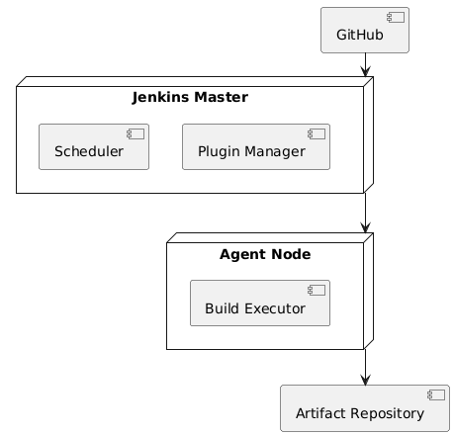
6.2 Jenkins Architecture

7. Case Study Analysis of CI Implementation
7.1 Netflix
Netflix operates at massive scale and relies heavily on CI to manage thousands of daily code changes. Jenkins is used to automate builds and testing, while Spinnaker supports continuous delivery. CI enables Netflix to deploy features rapidly while maintaining system reliability.
7.2 Amazon
Amazon follows a “you build it, you run it” philosophy. CI pipelines automatically build and test services whenever changes are committed. This approach allows Amazon to deploy code frequently while ensuring high availability and fault tolerance.
Comparison
Both organizations leverage CI to handle high deployment frequency, ensure code quality, and reduce operational risk. Automation is central to their success.

8. Traditional vs CI-Based Development Approaches
Traditional Development | CI-Based Development
Infrequent integration | Frequent integration
Manual testing | Automated testing
Late bug detection | Early bug detection
High integration risk | Reduced integration risk
Slower releases | Faster, reliable releases
CI transforms development from a reactive process into a proactive and automated workflow.

9. Return on Investment (ROI) of CI Implementation
The ROI of CI is primarily realized through cost savings and productivity gains. Early detection of defects reduces the cost of fixing bugs, which increases significantly when discovered in later stages. Automated testing and builds reduce manual effort, allowing developers to focus on feature development. Faster release cycles also provide competitive business advantages.
Although CI requires initial investment in tools and training, the long-term benefits outweigh the costs, making it a valuable strategic investment.

10. Conclusion
Continuous Integration is a fundamental practice in modern software engineering. By automating builds, testing, and integration, CI improves software quality, accelerates delivery, and enhances collaboration. Organizations across industries rely on CI to manage complexity and scale efficiently. When implemented correctly, CI serves as the foundation for successful DevOps and continuous delivery pipelines.

